Adding new Classification columns to the Caretaker List:

1. Log in at <http://cms.feralcatcaretakers.org> and select the **Administration** link:

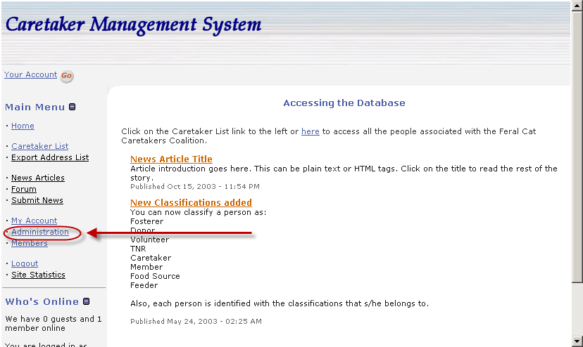

1. Next, select the **pnAddressBook** link:

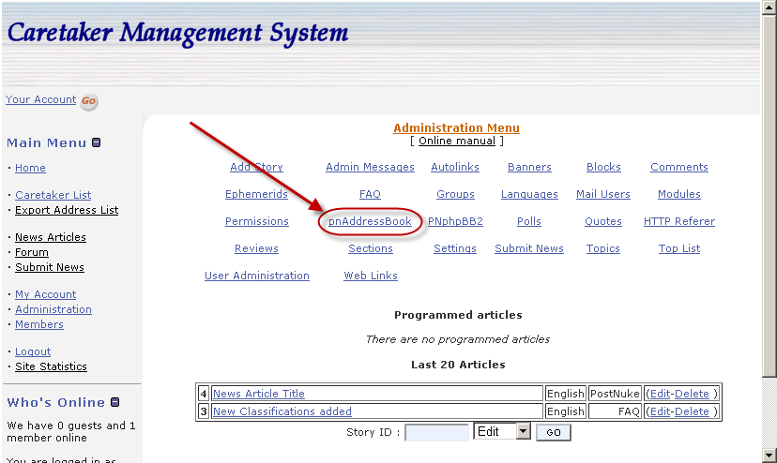

1. Next, select the **Custom Fields** link.

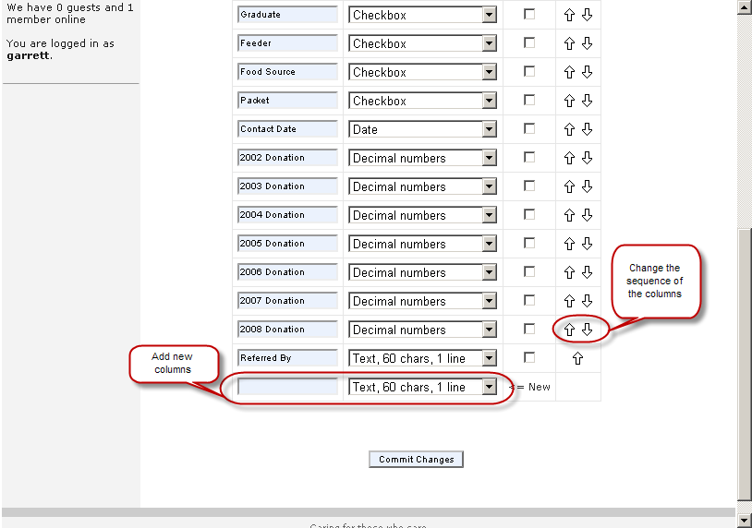

1. Add a new column as needed. Follow the examples above for instructions.